**Bresenham Line Algogrithm Output :**

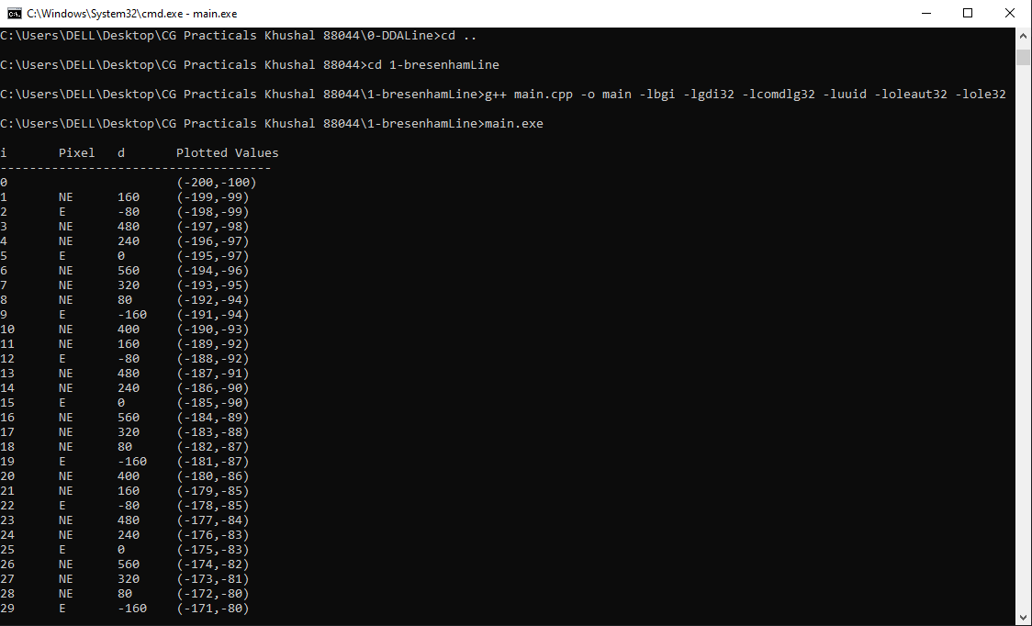

**Bresenham Line Algogrithm :**

